Math 231 Test #1

Your Name:

Please circle your discussion group (2 pt)

|  |  |  |
| --- | --- | --- |
| 1 Gan Yinliang B416 | 4 Zhang Jinghao B425 | 7 Loigen Sodian B416 |
| 2 Zhang Junwei B424 | 5 Xu Hang B419 |  |
| 3 Ke Wentao B419 | 6 Huang Nuoer B410 |  |

* You will have one hour for the exam.
* No notes, books or electronics during the exam.
* Do not open this test booklet until a proctor says start.
* For all free response questions, show work that justifies your answer.
* Raise your hand if you have a clarification question.
* Scratch paper is provided. You can ask for more if needed.
* Do not leave early: this disturbs others. If you finish your test early, check your work

or just relax.

* Quit working when the test ends and hand your test booklet to proctors.

|  |  |  |  |  |  |  |  |  |  |  |
| --- | --- | --- | --- | --- | --- | --- | --- | --- | --- | --- |
| Question | 1 | 2 | 3 | 4 | 5 | 6 | 7 | 8 | 9 | Total |
| Points | 12 | 10 | 10 | 10 | 12 | 8 | 16 | 10 | 10 | 98 |
| Score |  |  |  |  |  |  |  |  |  |  |

1. (12 points, 3 points each) Determine whether the statement is true or false. Circle the right answer.
2. Suppose $f$ is continuous on $[0, ∞)$, and $\lim_{x→∞}{f(x)}=1$, $\int_{0}^{∞}{f(x)dx}$ is convergent. (True or False)
3. Midpoint Rule is always more accurate than the trapezoidal rule. (True or False)
4. Since $\int_{2}^{∞}{\frac{dx}{\sqrt{x}}}$ diverges, and $\frac{1}{\sqrt{x}}<\frac{1}{\sqrt{x-1}}$ for all $x>2$, $\int_{2}^{∞}{\frac{dx}{\sqrt{x-1}}}$ must diverge. (True or False)
5. If $f$ is a positive function and $f"<0$ fpr $a≤x≤b$, show that $T_{n}<\int_{a}^{b}{f\left(x\right)dx}<M_{n}$. (True or False)

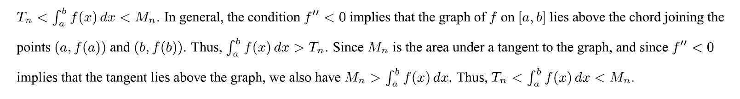

1. (10 points) Evaluate the following integral

$$\int{t}\sec^{2}{6t }dt$$

Solution

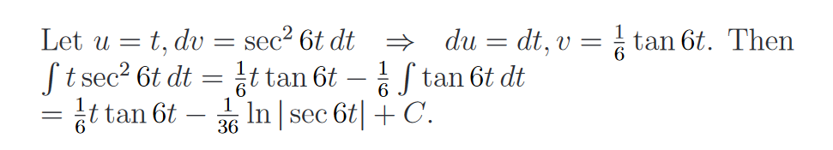

1. (10 points) Evaluate the following integral

$$\int{\sqrt{33+8x-x^{2}}}dx$$

Solution

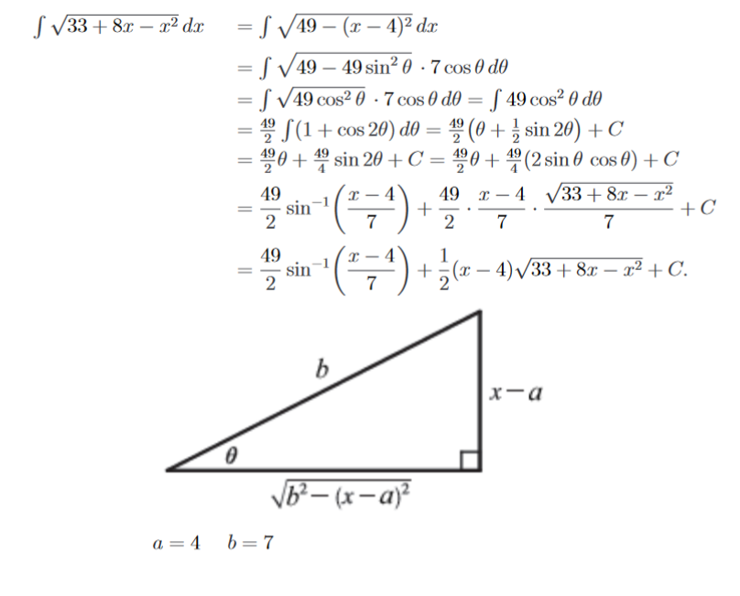

1. (10 points) Find the average value of $f\left(x\right)=6x^{2}\ln{x}$ on the interval [1,3].

Solution

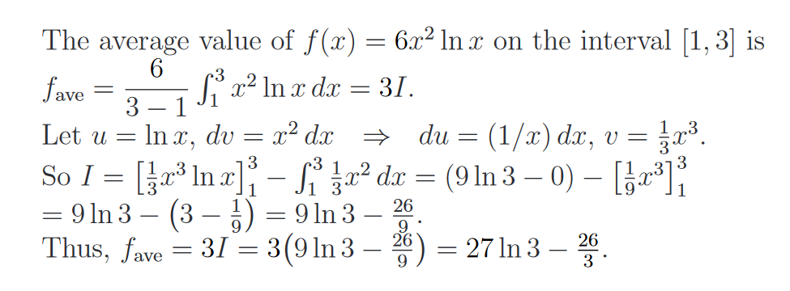

1. (12 points) Evaluate the following integral

$$\int{\frac{\sqrt{\left(1+\ln{x}\right)}}{xlnx}}dx$$

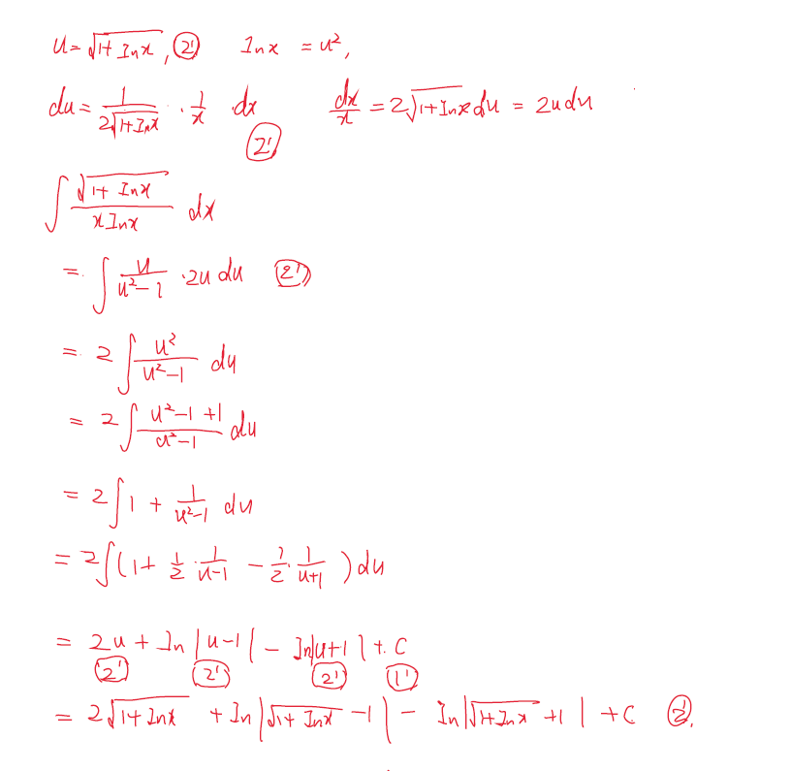

1. (8 points) Write out the form of the partial fraction decomposition of the function. Do not determine the values of the coefficients. (the fractions need to be the most simple forms)

$\frac{7x+1}{{\left(x+1\right)}^{3}{\left(x^{2}+9\right)}^{2}}$

Solution

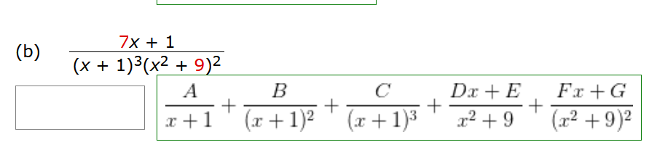

$\frac{x^{4}}{(x^{3}+x)(x^{2}-x+3)}$

Solution

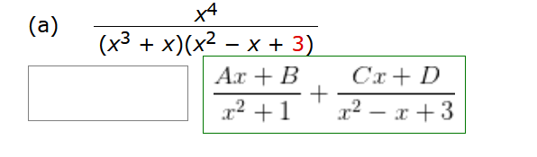

1. (16 points) Determine whether the integral is convergent or divergent.

$$\int_{-∞}^{20}{re^{\frac{r}{4}}dr }$$

* Convergent
* Divergent

Solution

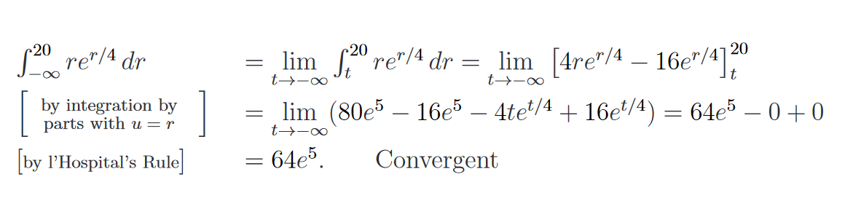

$\int_{e}^{∞}{\frac{49}{x{\left(\ln{x}\right)}^{3}}dr }$

* Convergent
* Divergent

Solution

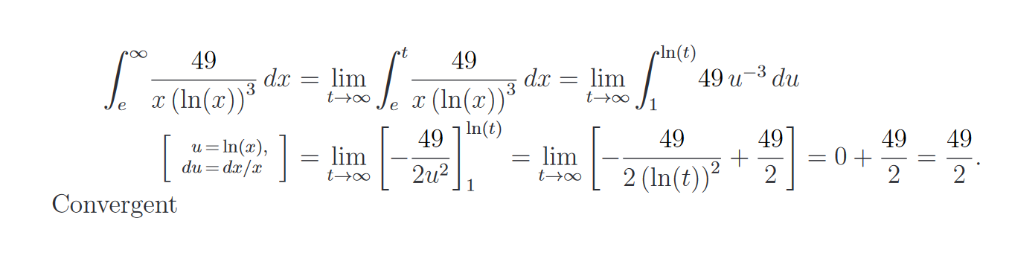

$\int_{2}^{3}{\frac{8}{\sqrt{3-x}}dx}$

* Convergent
* Divergent

Solution

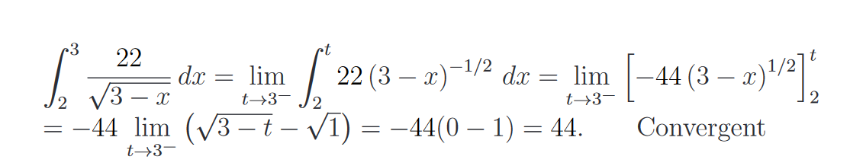

$\int_{0}^{3}{\frac{1}{x\sqrt{x}}dx}$

* Convergent
* Divergent

Solution

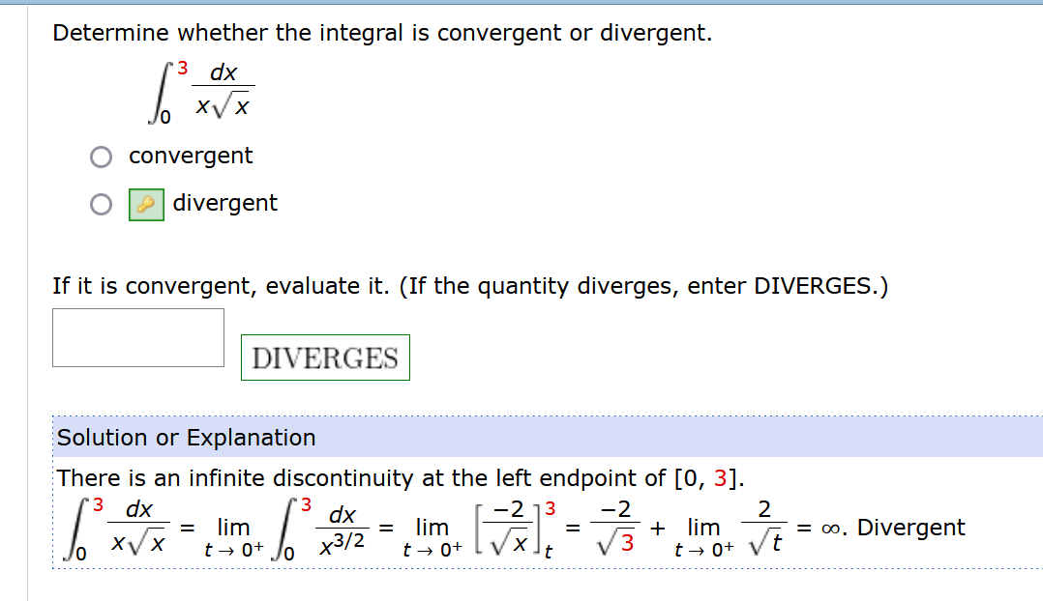

1. (10 points) Evaluate the integral

$$\int{\frac{1}{secθ+1}dθ}$$

Solution

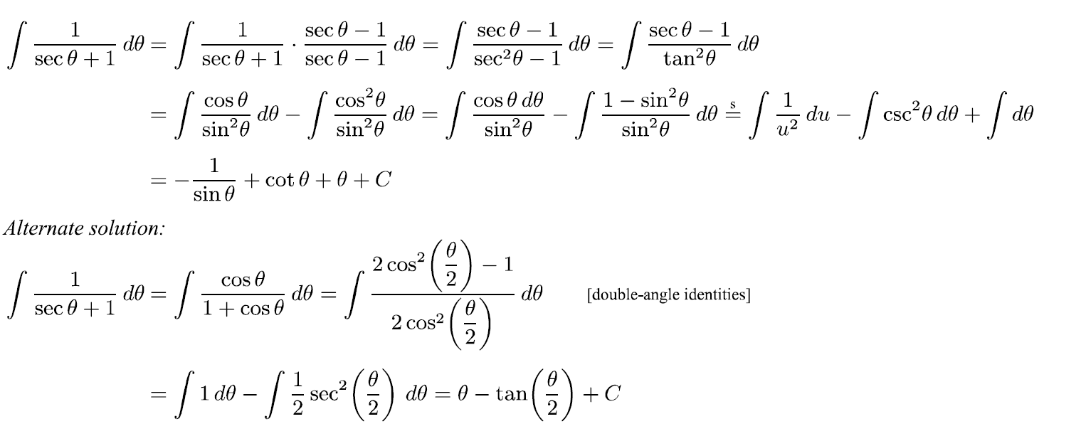

1. (10 points) A particle moves on a straight line with velocity function $v\left(t\right)=sinwtcos^{2}wt.$ Find its position function $s=f(t)$ if $f\left(0\right)=0$.

Solution

